Case 17-AM,C-Taino-Head-Fewkes Type 3-Basalt 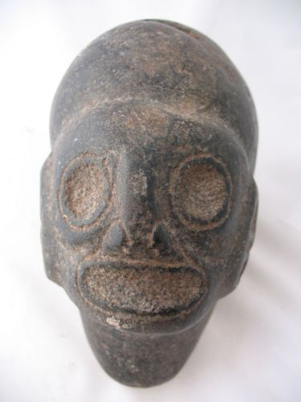

Case No.: 17
Accession Number:
Formal Label: Case 17-AM,C-Taino-Head-Fewkes Type 3-Basalt
Display Description:
Taino pre-historic stone heads may have originated from the practice of maintaining ossuaries of important caciques or shamans, since ancestor worship was a central aspect of Taino spirituality. In ceremonial practice these objects were the conduits to the spirit world and with anthropomorphic masks were consulted on issues of importance to the decision-making of the local community. This suggests that local decisions were community affairs. Features of these sculptures included head bands that may have indicated a particular cacique or group, ear elements that often included a round ear spool below the ear itself, the shape of the chin in various degrees of sharpness, and the shape of the mouth, whether it be open as if in pronouncing an utterance or closed showing only dentition, suggesting a deceased ancestor’s entombed skull as an object of reverence.

LC Classification:
Date or Time Horizon: before 1500
Geographical Area:
Map:
GPS Coordinates:
Cultural Affiliation:
Medium: Basalt
Dimensions: L 6 in, H 4.75 in, W 3.5 in
Weight: 5.5 lbs
Provenance:
Condition:
Discussion:
Jesse Walter Fewkes suggested three types of these anthropomorphic heads. The first is with an elongated, concave base. The second type is ovate with a flat base. The third type is a head with a short base.

References:

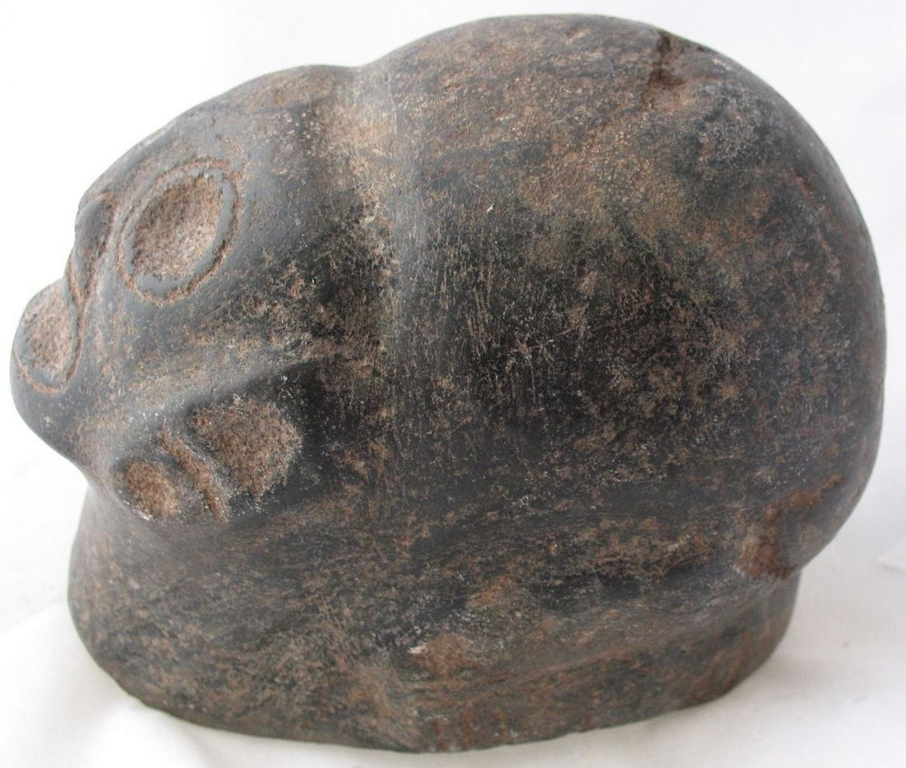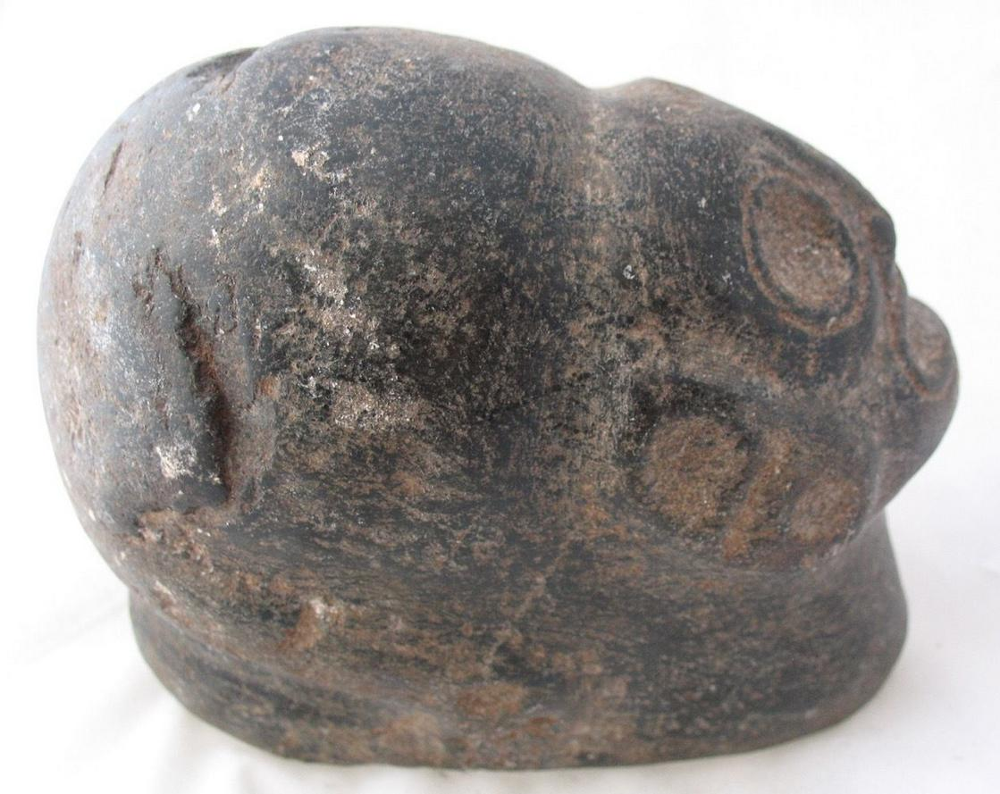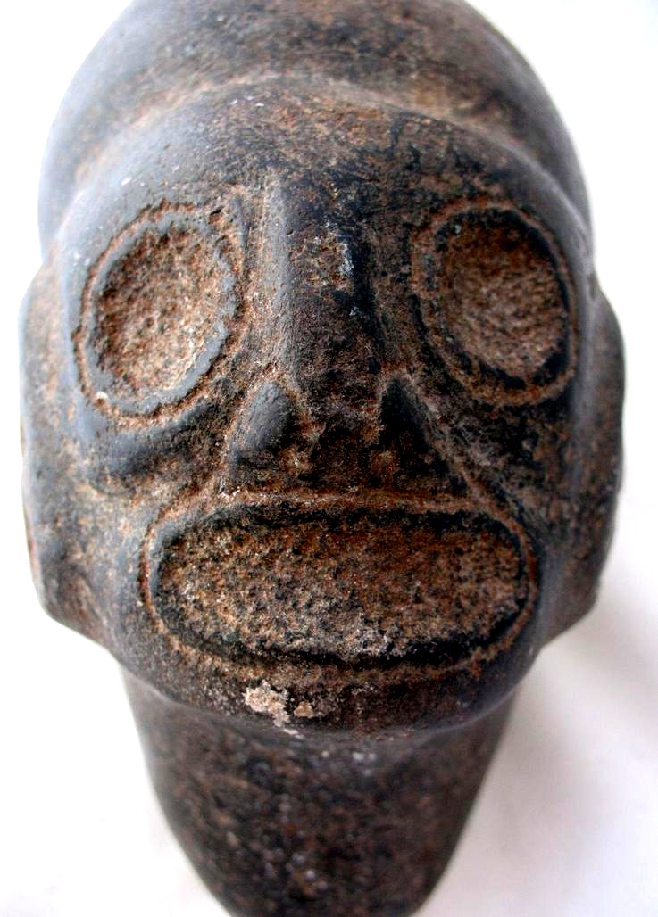
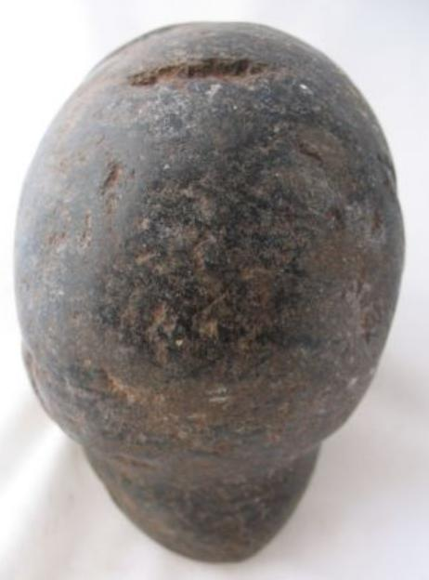

Winning bid:
US $271.00
[ 23 bids ]
Shipping:
$15.00 Expedited Shipping
Item location:
Fort Lauderdale, Florida, United States

